St. Xavier’s Catholic College of Engineering

Department of Information Technology

2023 – 2024 (Even Semester)

III Year Sixth Semester

**CCS342 DevOps**

**Syllabus**

|  |  |
| --- | --- |
| **COURSE OUTCOMES** | |
| CO1 | Explain the terminology and concepts of DevOps and version control tools. |
| CO2 | Perform Continuous Integration and Testing using Maven and Gradle. |
| CO3 | Apply Jenkins to automate continuous deployment. |
| CO4 | Perform deploy and configuration management using Ansible. |
| CO5 | Demonstrate Cloud-based DevOps tools using Azure DevOps. |

**PRACTICAL EXERCISES**:

|  |  |  |
| --- | --- | --- |
| **Sl.No.** | **List of Experiments** | **CO** |
|  | Create Maven Build pipeline in Azure | CO2 |
|  | Run regression tests using Maven Build pipeline in Azure | CO2 |
|  | Install Jenkins in Cloud | CO3 |
|  | Create CI pipeline using Jenkins | CO3 |
|  | Create a CD pipeline in Jenkins and deploy in Cloud | CO3 |
|  | Build a simple application using Gradle | CO4 |
|  | Create an Ansible playbook for a simple web application infrastructure | CO2 |
|  | Install Ansible and configure ansible roles and to write playbooks | CO4 |

|  |  |
| --- | --- |
| * 1. Staff-in-charge | * 1. HOD |
|  |  |

**Index Page**

|  |  |  |  |  |
| --- | --- | --- | --- | --- |
| **Sl.No.** | **Experiment Name** | **Mark** | **Date** | **Signature** |
|  | Create Maven Build pipeline in Azure |  |  |  |
|  | Run regression tests using Maven Build pipeline in Azure |  |  |  |
|  | Install Jenkins in Cloud |  |  |  |
|  | Create CI pipeline using Jenkins |  |  |  |
|  | Create a CD pipeline in Jenkins and deploy in Cloud |  |  |  |
|  | Build a simple application using Gradle |  |  |  |
|  | Create an Ansible playbook for a simple web application infrastructure |  |  |  |
|  | Install Ansible and configure ansible roles and to write playbooks |  |  |  |

|  |
| --- |
| **Date:** |
|  |
| **Ex No: 1** |
| **Create Maven Build pipeline in Azure** |
|  |
| **Aim**  To create a maven project and build a pipeline in Azure |
| **Procedure**   1. **Install Java and Maven and set the system environment variables** 2. Download maven and extract it 3. Add JAVA_HOME and MAVEN_HOME in environment variable    * 1. Right click on **MyComputer** -> **properties** -> **Advanced System Settings** -> **Environment variables** -> **click new button.**      2. Add **MAVEN_HOME** in variable name and path of maven in variable value. click on **OK** button. Similary create **JAVA_HOME** 4. Add maven and java path in environment variable    * 1. Click on new tab and then set the path of maven and java till bin directory. If it is set, edit the path and append the path of maven and java 5. Verify Maven and Java   open the command prompt and write:   1. mvn −version 2. java -version 3. **Create a github account** 4. Go to https://github.com/join in a web browser 5. Enter your personal details. 6. Click Verify to start the verification puzzle. 7. Click the green Create account button. 8. Verify your email by entering the code. 9. Select your preferences and click Continue. 10. Note the types of plans offered by GitHub. 11. Select the free plan. 12. **Create an Azure student login and enter into Azure DevOps**   **Create an Azure Student Account:**   * Visit the Azure for Students page. * Sign up using your university or school email. You’ll need to renew this account each year while you’re a student. * You’ll receive a USD 100 credit to use with Azure services. No credit card is required, and you get 12 months of free Azure services1.   **Sign Up for Azure DevOps:**   * Go to Azure DevOps. * Choose either a Microsoft account or a GitHub account to sign up. * If you don’t have a Microsoft account, create one. * Select Start free and enter your account credentials. * Azure DevOps will create an organization for you. * It will also create a project named after your newly created Microsoft account. * If you signed up with an existing Microsoft account, you’ll need to create a project next.   **Access Azure DevOps:**   * Sign in to your organization anytime at dev.azure.com{Your_Organization}.  1. **Install a Java IDE (Eclipse, NetBeans, IntelliJ IDEA, VS code)** 2. **Develop a Java Maven Project and build the application in the local server**   **Create a New Maven Project:**   * Open VS Code. * Install the Maven for Java extension by searching for it in the Extensions view (Ctrl+Shift+X). * Create a new Maven project using one of the following methods: * Use the command palette (Ctrl+Shift+P) and type “Maven: Create Maven Project.” * Right-click on a folder and select “Generate from Maven Archetype.” * Choose the “maven-archetype-quickstart” archetype. * Modify the pom.xml file to specify your project details and dependencies.   **Write Your Java Code:**   * Create your Java classes in the src/main/java directory. * Define your application logic, classes, and methods.   **Build the Project:**   * Open the integrated terminal in VS Code (Ctrl+`). * Run the following command to build the project:   mvn clean install   * This will compile your code, run tests, and package the application into a JAR file.   **Run the Application Locally:**   * After successful build, use the following command to start a local server:   java -jar target/your-artifact-id-version.jar   * Replace your-artifact-id-version with the actual name of your JAR file.   **Access Your Application:**   * Open a web browser and navigate to http://localhost:8080 (or the port specified in your application). * You should see your Java application running locally.  1. **Push the java maven project into Git Repository**   **Initialize Git Repository:**   * Open a terminal or command prompt. * Navigate to the root directory of your Maven project using the cd command. * Initialize a new Git repository:   git init  **Add and Commit Your Files**:   * Use the following commands to stage all files and commit them:   git add .  git commit -m "Initial commit"  **Create a New Repository on GitHub:**   * Go to GitHub and log in (or sign up if you don’t have an account). * Click the “+” icon in the top right corner and select “New repository.” * Give your repository a name, choose visibility (public or private), and create it. * Link Your Local Repository to GitHub: * Copy the HTTPS URL of your newly created GitHub repository. * In your terminal, add the remote origin (replace <me> with your GitHub username and <myrepo> with your repository name): * git remote add origin https://github.com/<me>/<myrepo>.git   **Push your code to the master branch on GitHub:**   * git push -u origin master  1. **Create Azure DevOps organization and import or clone the git repo of the java maven project**   **Sign in to Azure DevOps:**   * Log in to your Azure DevOps organization. * Select Your Project: * Choose the project where your Java Maven project resides. * CCreate a New Git Repo in Your Project: * Open the Repos page in your project by browsing to dev.azure.com/OrganizationName. * Hover over the name of your project and select the Repos icon. * From the repo drop-down, select New repository. * Verify that Git is the repository type and enter a name for your new repository. * Optionally, add a README and create a .gitignore file. * Select Create.  1. **Create a pipeline in Azure and build the project**   **Create a New Pipeline:**   * Navigate to Pipelines (usually on the left side menu). * Click on New pipeline. * Select Azure Repos Git as the source location.   **Choose Your Repository:**   * Select the Git repository where your Java Maven project is hosted. * Configure the Pipeline:   **You’ll be guided through a wizard:**   * First, choose the Maven, Gradle, or Ant template based on your build preference. * Save your configuration. * Commit an azure-pipelines.yml file to your repo. * Save and run the pipeline.   **Watch Your Pipeline in Action:**   * If you want to see your pipeline executing, select the build job.   **Customize Your Pipeline:**   * When you’re ready to make changes, go to the Pipelines page, select your pipeline, and edit the azure-pipelines.yml file. |
| **Output**  **🡪Project Settings**       1. Choose Agent pools. 2. Click on Add pool. 3. Select Pool-type as Self-hosted, give it a name and click on Create. 4. Click on the created agent pool. |
| **Conclusion** |

To create an Agent:

* Click on organization setting

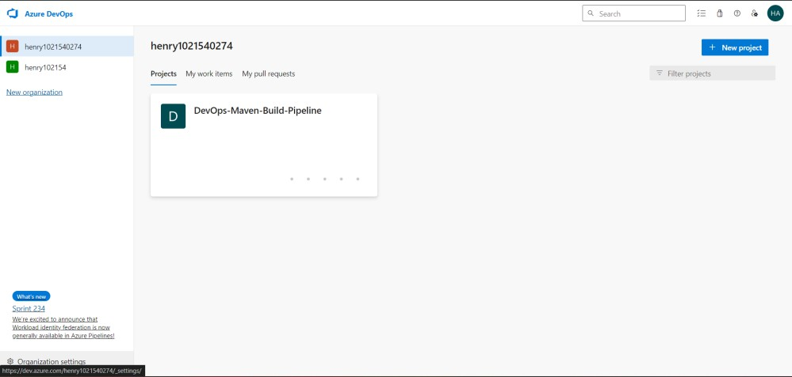

* 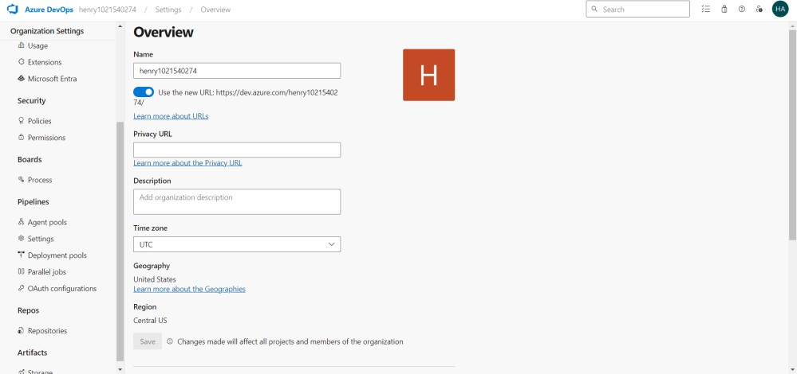Create a new pool in Agent Pools

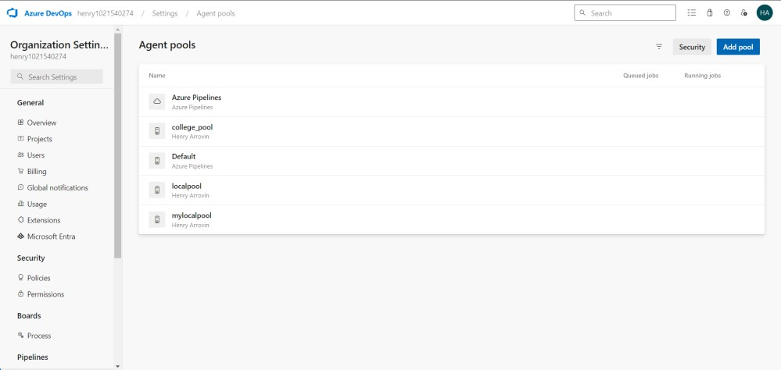

* Create a new Agent

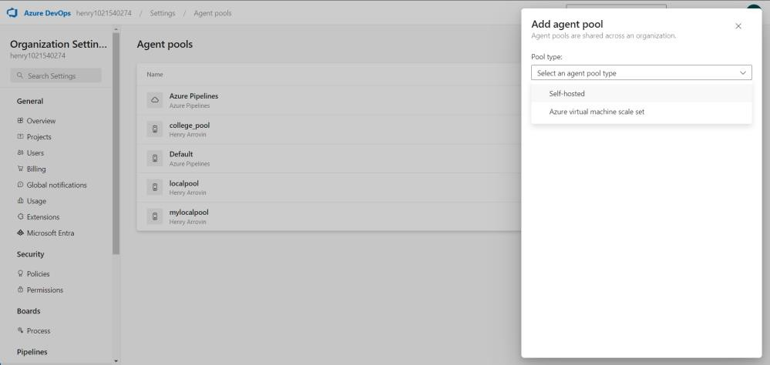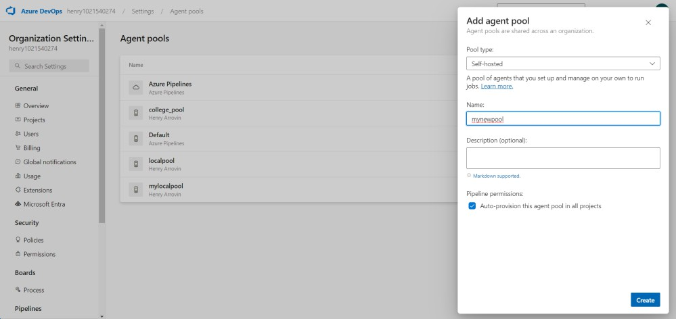

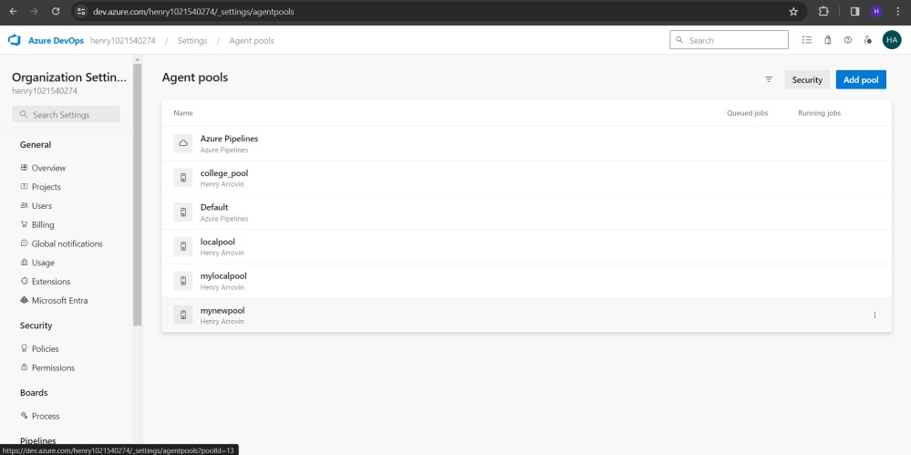

* Go inside the pool created and create a new agent

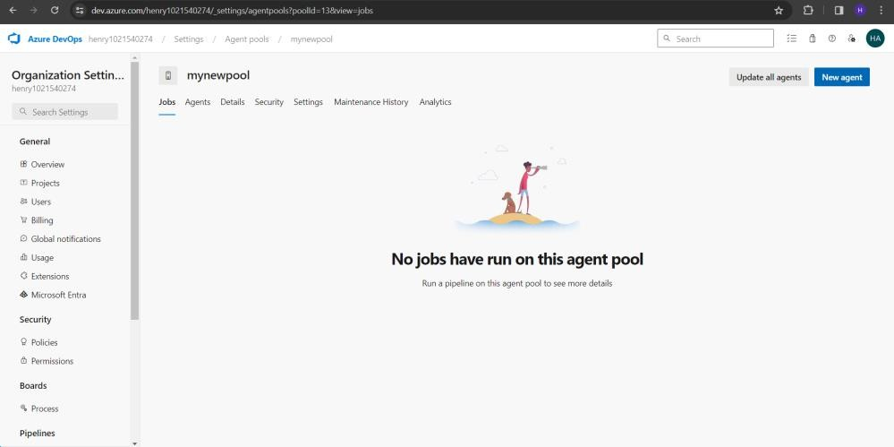

* Follow the steps shown in the screen

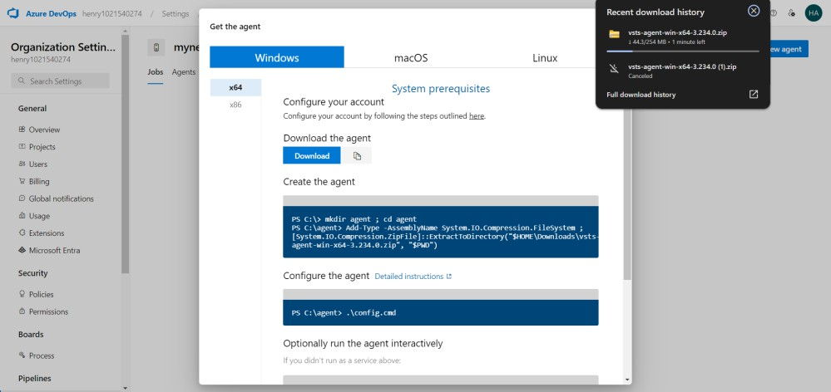

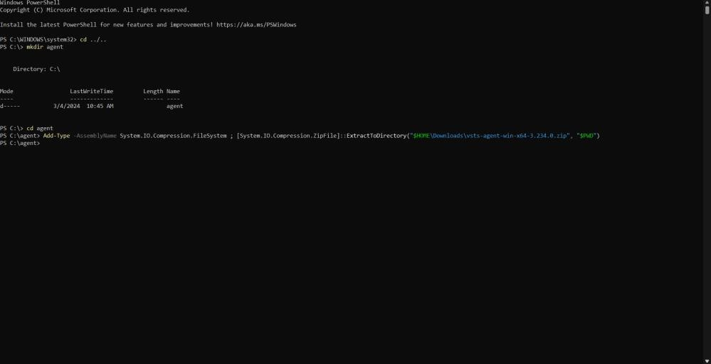

* Give the URL till organization name
* For PAT follow the below steps
* Click on Personal Access Tokens

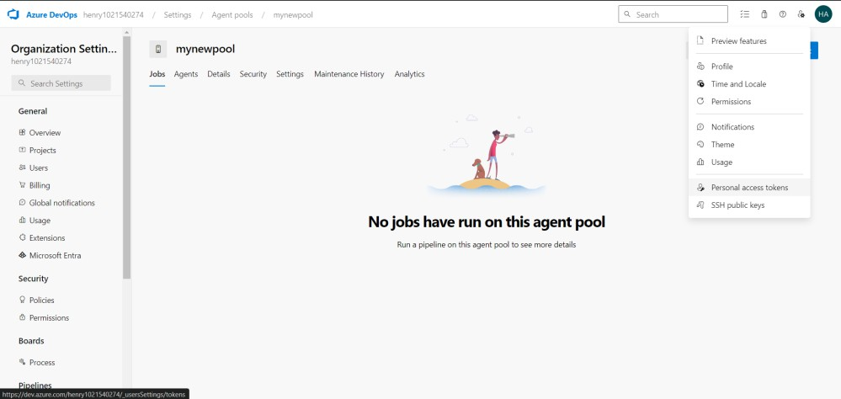

* Create a new token

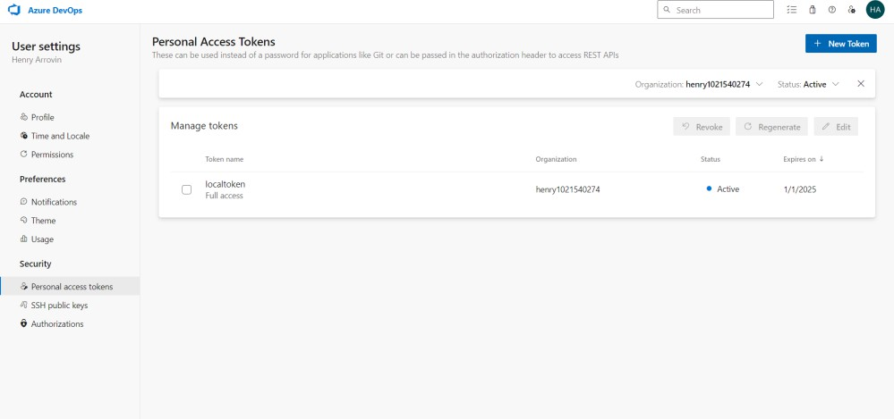

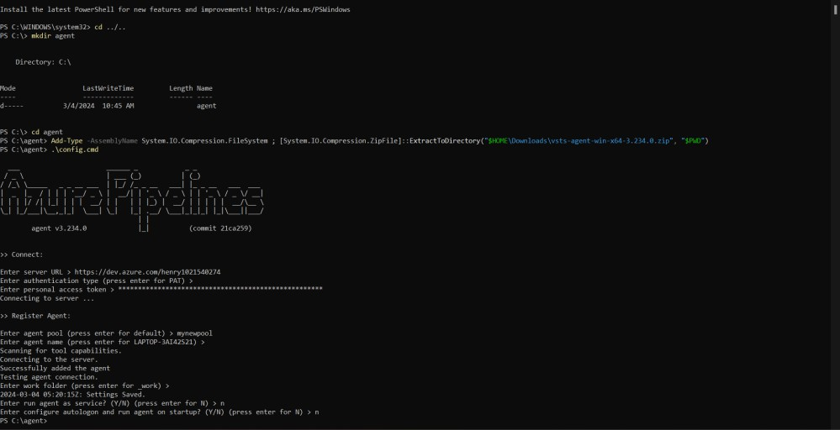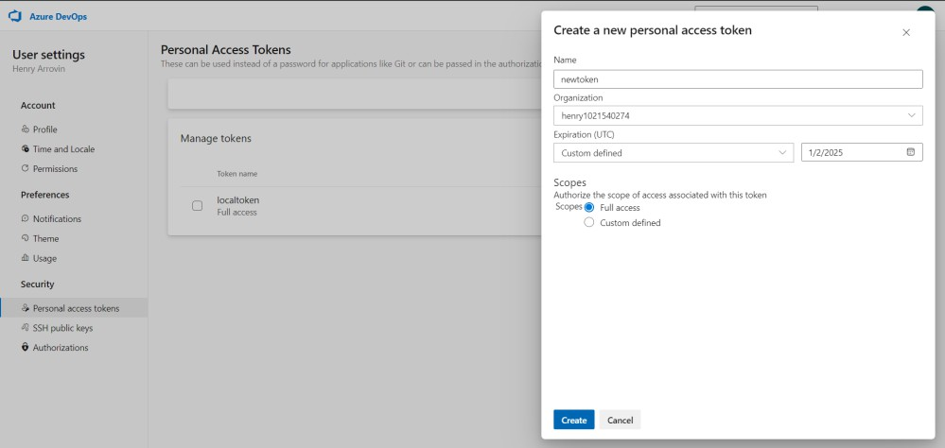

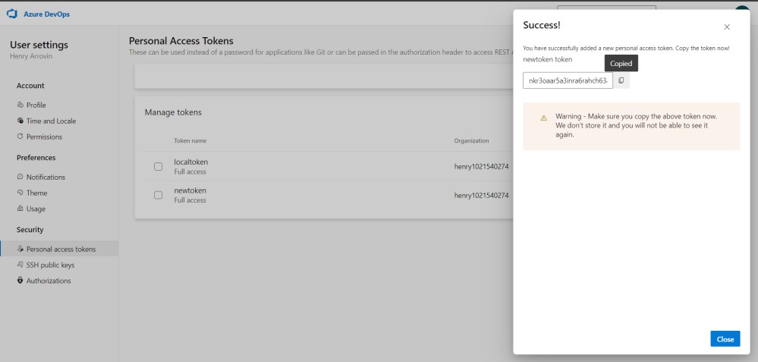

* Copy the token and paste it

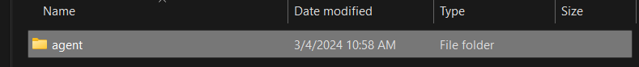

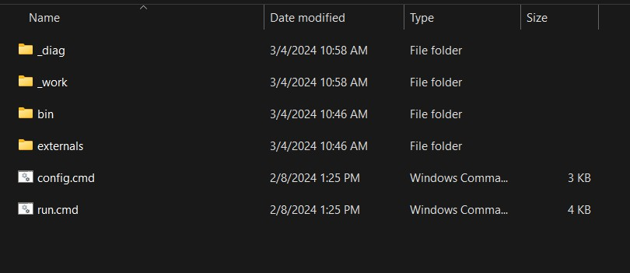

Now to create a pipeline

* + Go to pipelines in Azure Devops

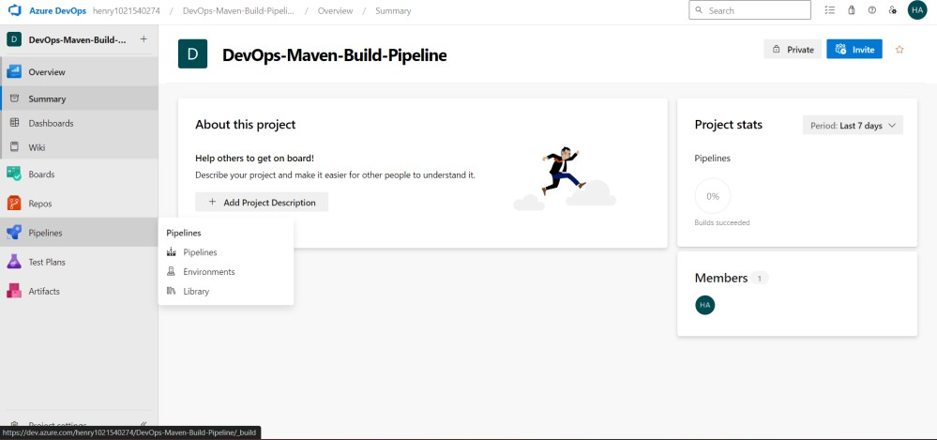

* + Click GitHub or where your code is stored
  + GitHub is used in this Demo

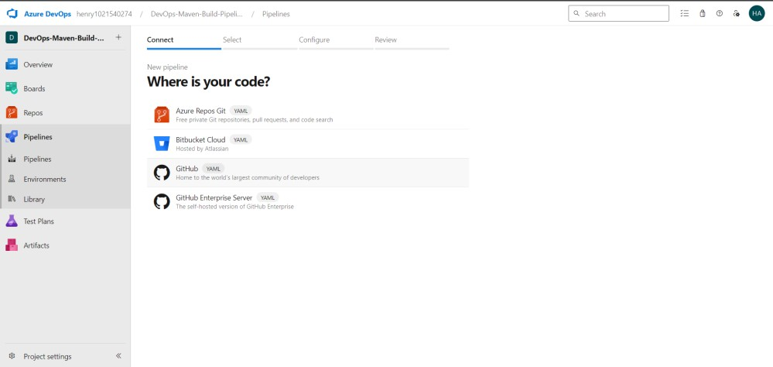

* + Choose your source code

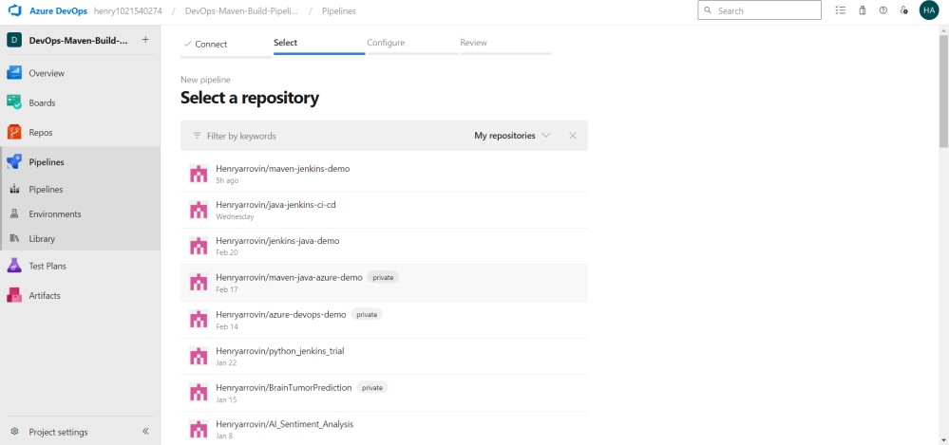

* + Make sure it is a maven project by verifying whether there is pom.xml in that project

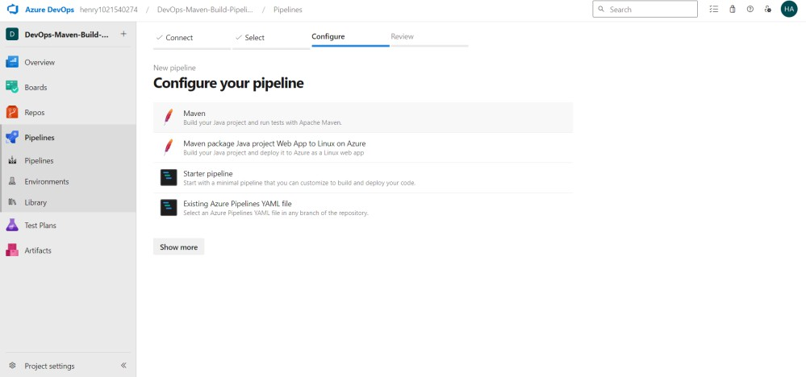

* + Since maven project click on Maven to Generate a sample YAML script for basic test and build

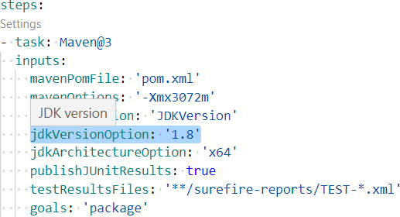

* + Since we want to create an artifact (jar/war) change the YAML script as given below

trigger:

* master

pool: mynewpool

**Conclusion**

Thus, a maven project was created and build a pipeline in Azure

|  |
| --- |
| **Date:** |
| **Ex No: 2** |
| **Run regression tests using Maven Build pipeline in Azure** |
|  |
| **Aim**  To create a maven project and build a pipeline in Azure and create test cases to run regression test |
| **Procedure**  **Create a Maven Project:**  If you haven’t already, create a basic Java project with the following structure:   * package main:   + Main class   + Calculator class   + Add method * package test:   + CalculatorTest class   + addTest method * Ensure that your tests use the JUnit framework.   **Azure DevOps Pipeline Configuration:**   * In your Azure DevOps project, import your Java project from GitHub. * Create a new pipeline using the starter template. * Modify the pipeline YAML file to include the necessary tasks.   **Configure the Pipeline YAML:**   * Define the trigger (e.g., on each commit to the master branch). * Specify the VM image (e.g., ‘Ubuntu-16.04’). * Add tasks to build, test, and deploy your project. For testing, you’ll need to run your JUnit tests.   **Run Tests Automatically:**   * To run your tests automatically after each commit, follow these steps: * Open the Test Plans web portal. * Select your test plan. * Choose a test suite containing your automated tests. * Select the specific tests you want to run. * Click “Run test.” * Ensure that the test binaries are available in the build artifacts generated by your build pipeline.   **View Results:**   * You’ll see the test results (including code coverage) in the pipeline summary. * For code coverage, consider integrating tools like JaCoCo or Cobertura.   **Publish Build Artifacts:**   * To publish build artifacts, add the following task to your pipeline YAML:   + task: PublishBuildArtifacts@1   Note that the warning “Directory ‘/home/vsts/work/1/a’ is empty” means that no files were found to include in the artifact. Make sure your build generates the necessary output files. |

**Output**

steps:

* script: echo "Stage 1 - Setting up Java version."
* task: Maven@3 inputs:

mavenPomFile: 'pom.xml' mavenOptions: '-Xmx3072m' javaHomeOption: 'JDKVersion' jdkArchitectureOption: 'x64' publishJUnitResults: true

testResultsFiles: '**/surefire-reports/TEST-*.xml' goals: 'package'

* script: echo "Stage 2 - Maven build and test completed successfully."
* task: PublishBuildArtifacts@1 inputs:

PathtoPublish: '$(System.DefaultWorkingDirectory)/target' ArtifactName: 'my-java-artifacts'

publishLocation: 'container'

* script: echo "Stage 3 - Artifacts published successfully."
* task: PublishTestResults@2 inputs:

testResultsFormat: 'JUnit'

testResultsFiles: '**/surefire-reports/TEST-*.xml' failTaskOnFailedTests: true

searchFolder: '$(System.DefaultWorkingDirectory)'

* script: echo "Regression test is successfully completed."

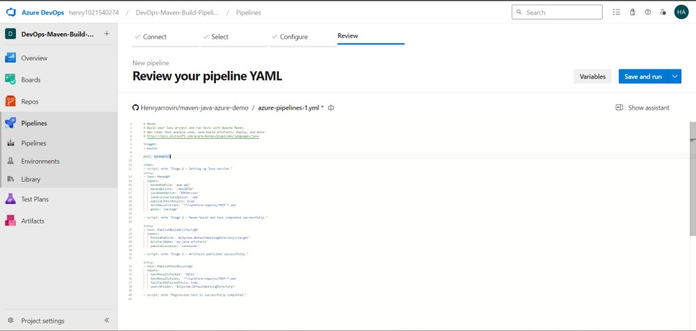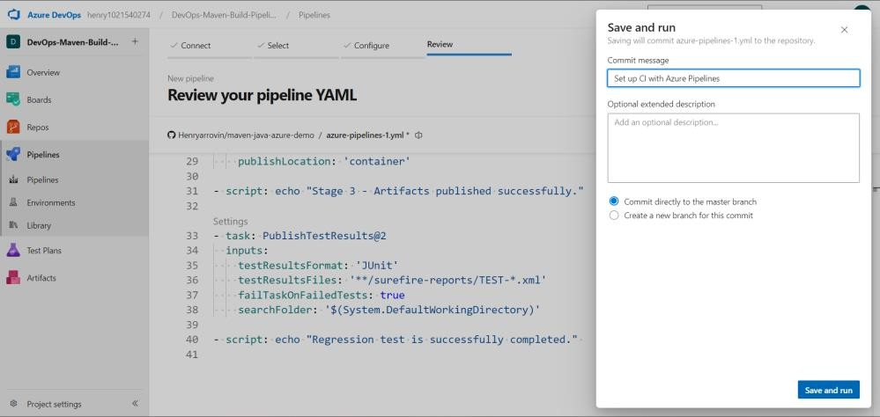

* + Commit the YAML script to the main branch directly or to a newly created branch and merge it to the main branch.
  + If the pipeline has no access, then give permission by clicking on to

“Permission Needed”.

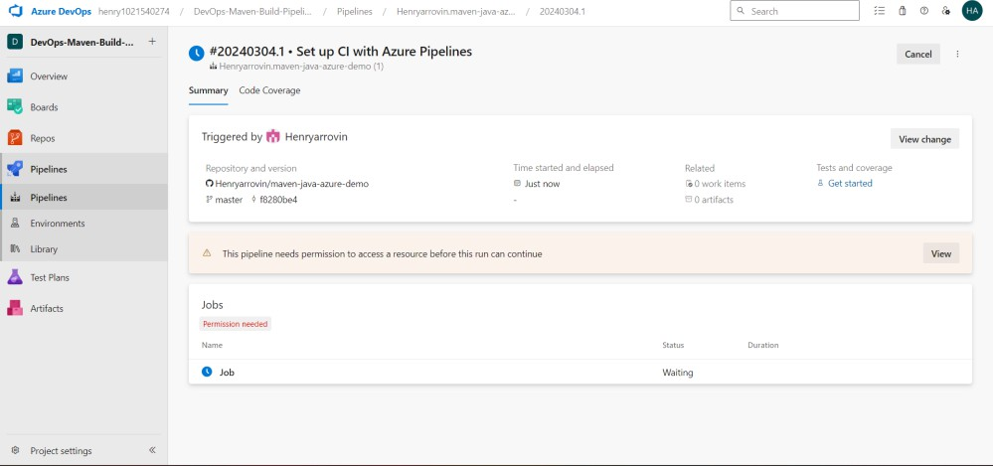

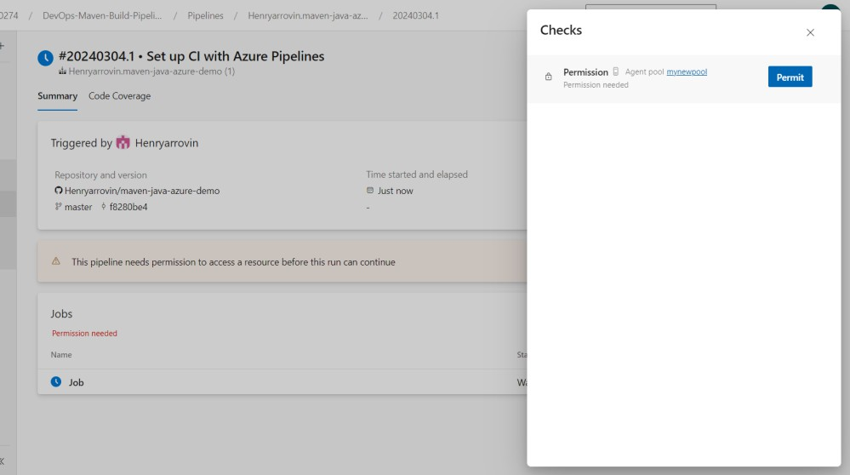

* + Don’t forget to run the agent created using the run command so that our

agent can be used to run the job.

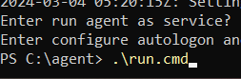

* + Now if we run pipeline or commit any changes in our code the job will get executed.

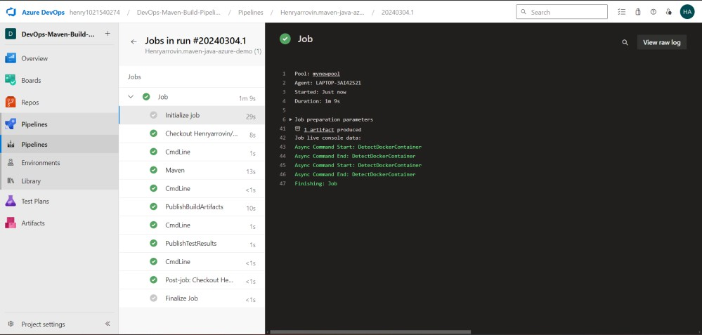

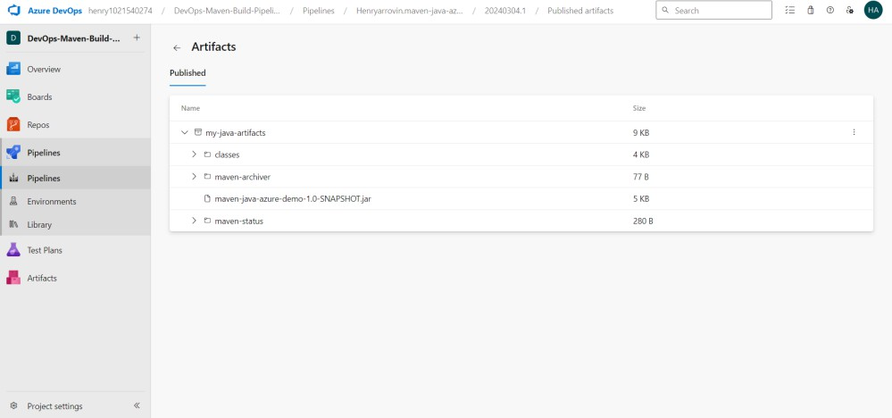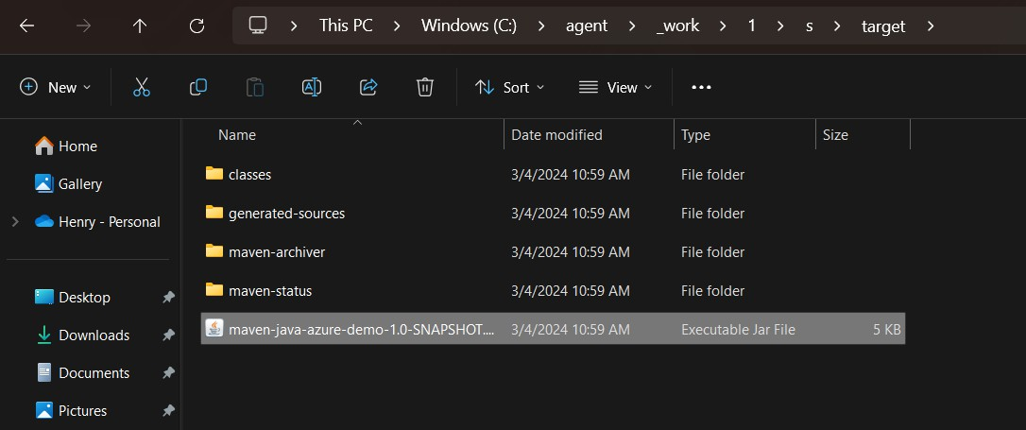

**Conclusion**

Thus a regression test cases are executed using Maven Build pipeline in Azure

|  |
| --- |
| **Date:** |
| **Ex No: 3** |
| **Install Jenkins in Cloud** |
|  |
| **Aim**  To install Jenkins in Cloud |
| **Procedure**  **Windows**   Downloading Jenkins from the link <https://www.jenkins.io/download/> stable LTS release of the Windows installer. After the download completes, open the Windows installer and follow the steps below to install Jenkins.  **Step 1: Setup wizard**  On opening the Windows Installer, an **Installation Setup Wizard** appears, Click **Next** on the Setup Wizard to start your installation.  Windows Installation Setup Wizard  **Step 2: Select destination folder**  Select the destination folder to store your Jenkins Installation and click **Next** to continue.  Jenkins Installation Destination  **Step 3: Service logon credentials**  When Installing Jenkins, it is recommended to install Jenkins using **LocalSystem(Windows equivalent of root)** which will grant Jenkins full access to your machine and services. click on **Test Credentials** to test your domain credentials and click on **Next**.  Jenkins Service Logon Credentials  **Step 4: Port selection**  Specify the port on which Jenkins will be running, **Test Port** button to validate whether the specified port if free on your machine or not. Consequently, if the port is free, it will show a green tick mark as shown below, then click on **Next**.  Jenkins Select Port  **Step 5: Select Java home directory**  The installation process checks for Java on your machine and prefills the dialog with the Java home directory.  Select Java Home Directory  **Step 6: Install Jenkins**  Click on the **Install** button to start the installation of Jenkins.  Windows Install Jenkins  **Step 7: Finish Jenkins installation**  Once the installation completes, click on **Finish** to complete the installation.  Finish Install  **Post-installation setup wizard**  After downloading, installing and running Jenkins, the post-installation setup wizard begins. **Unlocking Jenkins** When you first access a new Jenkins instance, you are asked to unlock it using an automatically-generated password.  **Step 1**  Browse to http://localhost:8080 (or whichever port you configured for Jenkins when installing it) and wait until the **Unlock Jenkins** page appears.  Unlock Jenkins page  **Step 2**  The initial Administrator password should be found under the Jenkins installation path. For default installation location to C:\Program Files\Jenkins, a file called **initialAdminPassword** can be found under C:\Program Files\Jenkins\secrets.  Jenkins Initial Password Location  **Step 3**  Open the highlighted file and copy the content of the **initialAdminPassword** file.  Jenkins Initial Password File  **Step 4**  On the **Unlock Jenkins** page, paste this password into the **Administrator password** field and click **Continue**.  Windows Jenkins Log File  This password must be entered in the setup wizard on new Jenkins installations before you can access Jenkins’s main UI.  **Customizing Jenkins with plugins**  After [unlocking Jenkins](https://www.jenkins.io/doc/book/installing/windows/#unlocking-jenkins), the **Customize Jenkins** by installing any number of useful plugins as part of your initial setup.  Click one of the two options shown:   * **Install suggested plugins** - to install the recommended set of plugins, which are based on most common use cases. * **Select plugins to install** - to choose which set of plugins to initially install. When you first access the plugin selection page, the suggested plugins are selected by default.  **Creating the first administrator user** Finally, after [customizing Jenkins with plugins](https://www.jenkins.io/doc/book/installing/windows/#customizing-jenkins-with-plugins), Jenkins asks you to create your first administrator user.   1. When the **Create First Admin User** page appears, specify the details for your administrator user in the respective fields and click **Save and Finish**. 2. When the **Jenkins is ready** page appears, click **Start using Jenkins**.     Re login every time using the local host with the port no. http://localhost:8080/    Google Cloud Platform (GCP):   * Ensure you have a Google Cloud account. If not, you can create one. * Follow the tutorial on Jenkins on Google Cloud to set up Jenkins on Google Compute Engine. This guide assumes familiarity with Packer (for creating images) and Jenkins itself.   Amazon Web Services (AWS) EC2:   * Launch an EC2 instance. * In the security group of the instance, open port 8080. * SSH into the EC2 instance using EC2 Instance Connect. * Install Jenkins on the EC2 instance. You can follow the steps outlined in this tutorial2.   Running CloudFormation from GitHub using Jenkins on EC2:   * Install the CloudFormation plugin in Jenkins. * Run a CloudFormation template from a GitHub repository using the plugin. * Optionally, you can also install the AWS CLI without using keys by leveraging SSM Session Manager   Note that the warning “Directory ‘/home/vsts/work/1/a’ is empty” means that no files were found to include in the artifact. Make sure your build generates the necessary output files.  **Azure**  Configure Your Environment:   * Ensure you have an Azure subscription. If not, create a free account. * Open Azure Cloud Shell (you can skip this step if you already have a session open).   Create a Virtual Machine:   * In Cloud Shell, create a test directory (let’s call it jenkins-get-started). * Switch to the test directory. * Create a file named cloud-init-jenkins.txt.   Paste the following code into the new file:  #cloud-config  package_upgrade: true  runcmd:  - sudo apt install openjdk-11-jre -y  - curl -fsSL [^1^][5] | sudo tee /usr/share/keyrings/jenkins-keyring.asc > /dev/null  - echo 'deb [signed-by=/usr/share/keyrings/jenkins-keyring.asc] [^2^][6] binary/' | sudo tee /etc/apt/sources.list.d/jenkins.list > /dev/null  - sudo apt-get update && sudo apt-get install jenkins -y  - sudo service jenkins restart  Run the following commands:  az group create --name jenkins-get-started-rg --location eastus  az vm create \  --resource-group jenkins-get-started-rg \  --name jenkins-get-started-vm \  --image UbuntuLTS \  --admin-username "azureuser" \  --generate-ssh-keys \  --public-ip-sku Standard \  --custom-data cloud-init-jenkins.txt  Verify the creation of the new virtual machine:  az vm list -d -o table --query "[?name=='jenkins-get-started-vm']"  Configure Jenkins:  Retrieve the public IP address of the virtual machine:  az vm show --resource-group jenkins-get-started-rg --name jenkins-get-started-vm -d --query "[publicIps]" --output tsv  SSH into the virtual machine using the IP address:  ssh azureuser@<ip_address>  Upon successful connection, you’ll see the prompt: azureuser@jenkins-get-started-vm. |
| **Output**  **Type in the url localhost:8080** |
|  |
| **To use the installed Jenkins in Azure Cloud type the following link**  [**http://52.190.63.117:8080/**](http://52.190.63.117:8080/) |
|  |

|  |
| --- |
| **Conclusion**  Thus, the Jenkins was successfully installed. |

|  |
| --- |
| **Date:** |
| **Ex No: 4** |
| **Create CI pipeline using Jenkins** |
|  |
| **Aim**  To create CI pipeline using Jenkins |
| **Procedure**  **Log in to Jenkins:**   * Access your Jenkins account. * If you haven’t installed Jenkins yet, follow the Jenkins installation guide.   **Create a New Jenkins Project:**   * Once logged in, you’ll be redirected to the Jenkins console. * Click on “New Item” in the dashboard. * Choose a suitable name for your pipeline project. * Select the “Pipeline” option.   Configure Your Pipeline:   * In the pipeline configuration, you can define your stages. A typical CI/CD pipeline includes stages like: * Test code: Run tests to ensure code quality. * Build Application: Compile and package your application. * Push to Repository: Store artifacts in a version control system (e.g., Git). * Deploy to Server: Deploy your application to different environments (e.g., Dev, Test, Production).   Pipeline Script:   * In the pipeline configuration, you’ll find a section to write your pipeline script. * You can use either declarative syntax or scripted syntax.   Here’s a simple example of a declarative pipeline script:  pipeline {  agent any  stages {  stage('Test code') {  steps {  // Run tests here  }  }  stage('Build Application') {  steps {  // Compile and package your app  }  }  stage('Push to Repository') {  steps {  // Push artifacts to Git  }  }  stage('Deploy to Server') {  steps {  // Deploy to different environments  }  }  }  }  Save and Run:   * Save your pipeline configuration. * Click “Build Now” to trigger the pipeline execution. * Jenkins will execute each stage sequentially. |

# **Output**

# Step 1

Since I am using Docker to host Jenkins, I will start the Jenkins container by pulling it. Alternatively, Jenkins can also be hosted by installing it directly on a server or virtual machine, configuring it, and then starting the Jenkins service.

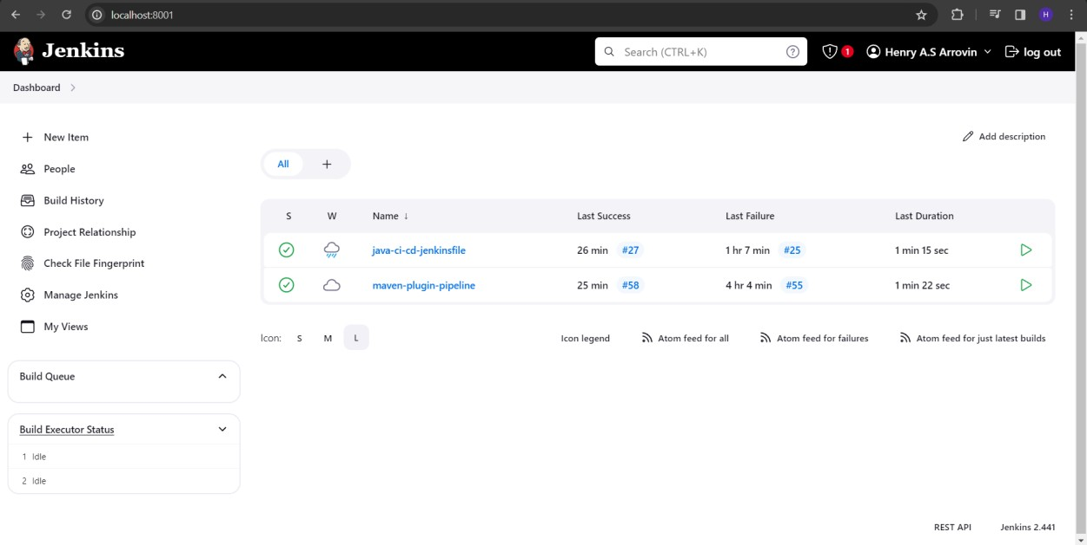

# Step 2

Click on new Item to create a new Pipeline project.

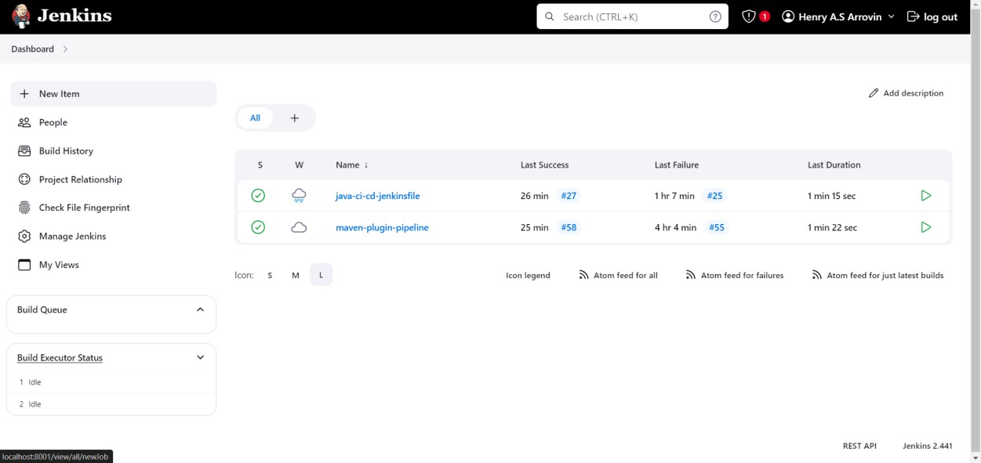

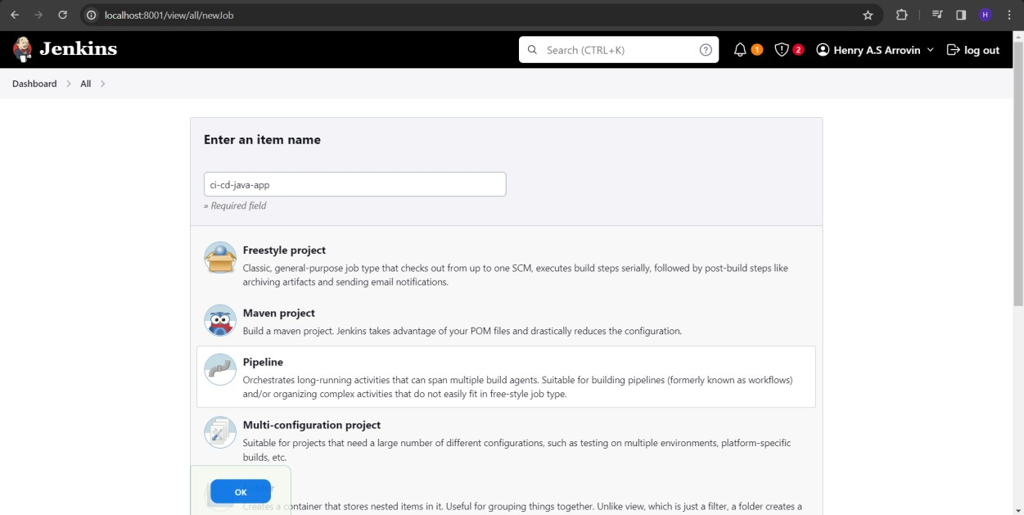

Configure the pipeline to run a job every minute using the cron syntax '* * * * *' and trigger the pipeline whenever a commit is made in GitHub.

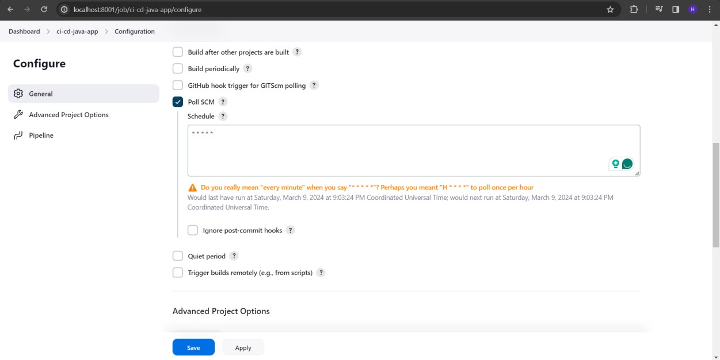

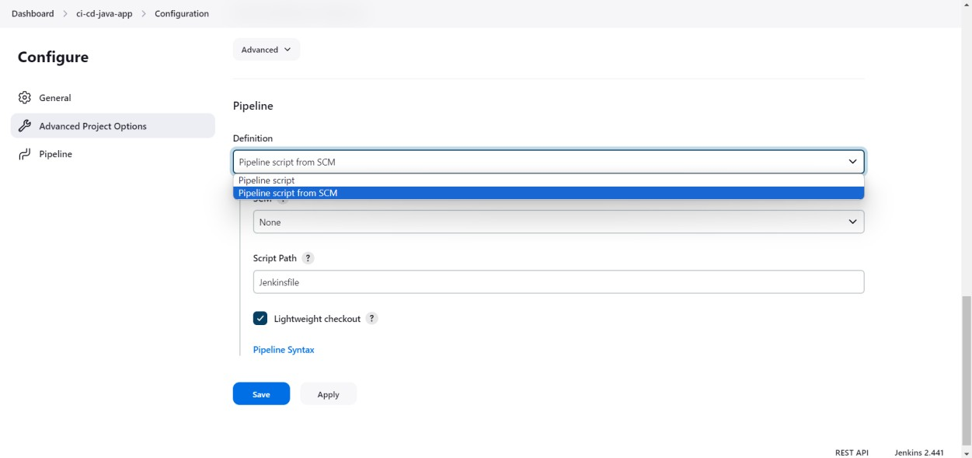

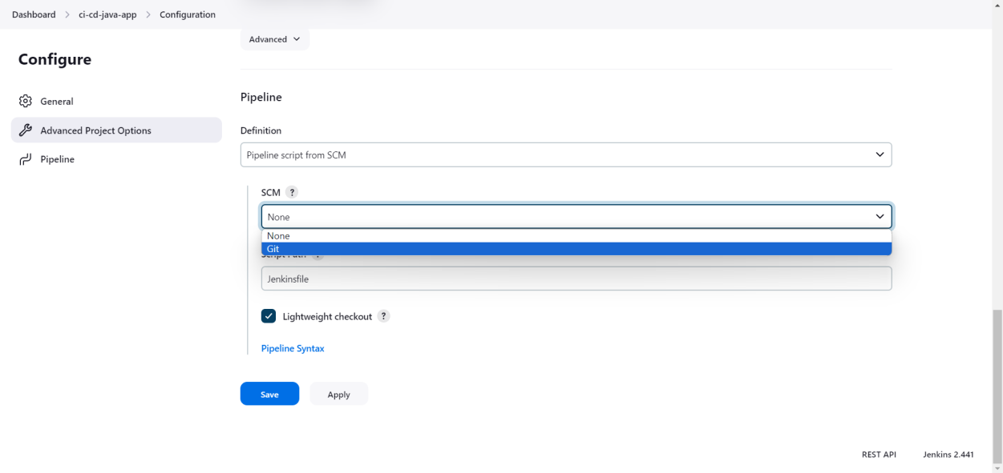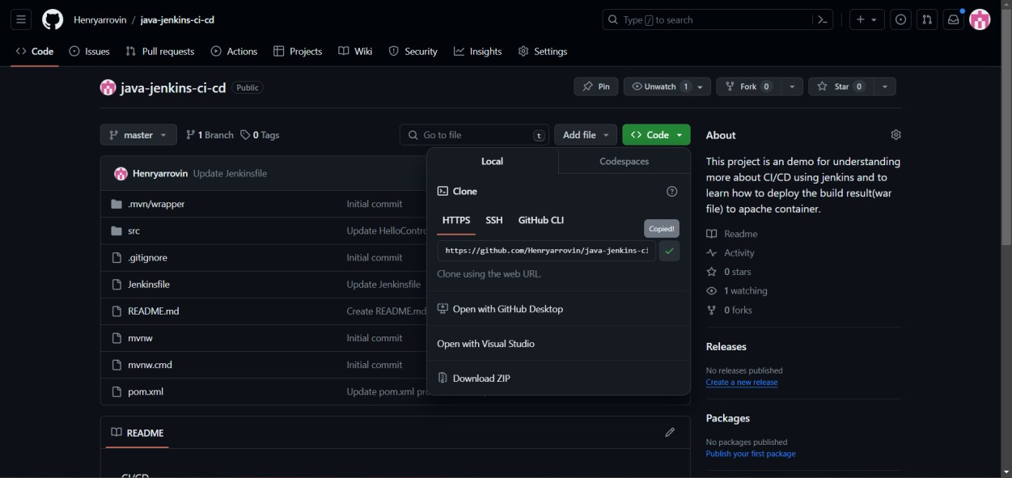

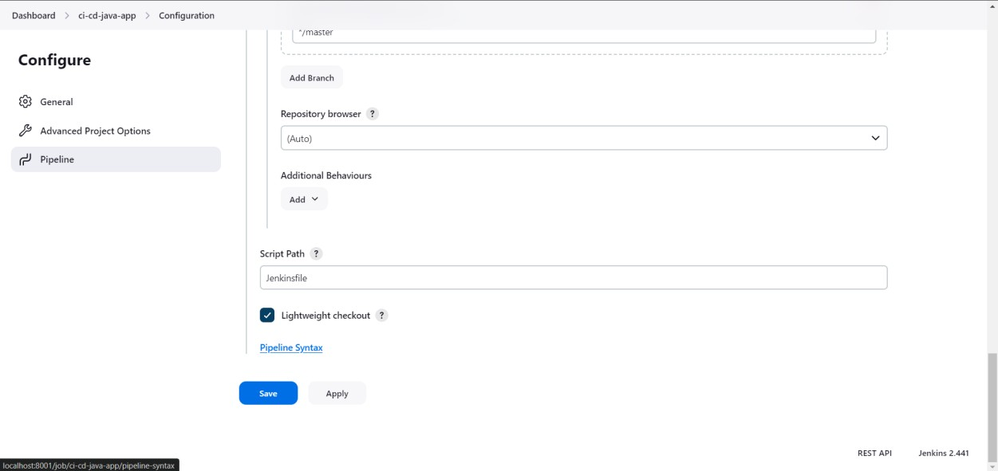

Generate the pipeline syntax for deploying the application's artifact to the Tomcat server, specifying the context path as '/your-context-path'. This will automate the deployment process as part of your continuous integration pipeline.

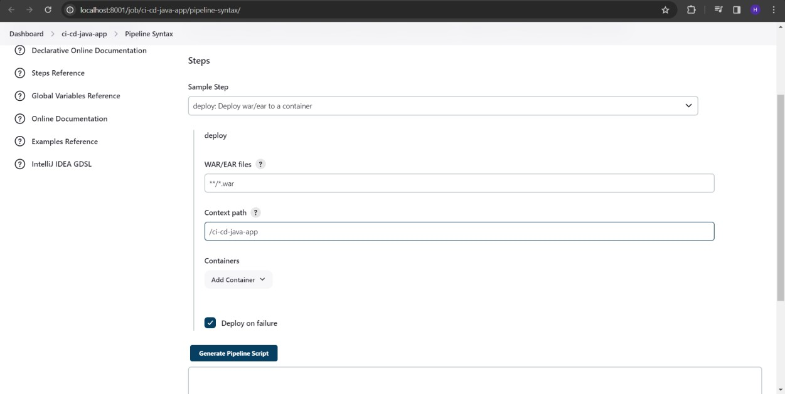

Choose the installed Tomcat version on your system and provide the credentials for the Tomcat Manager application. Additionally, in the advanced manager context path, specify '/manager/text' as it is crucial for receiving an 'OK' message, ensuring the success of the deployment process.

Follow the steps below for guidance.

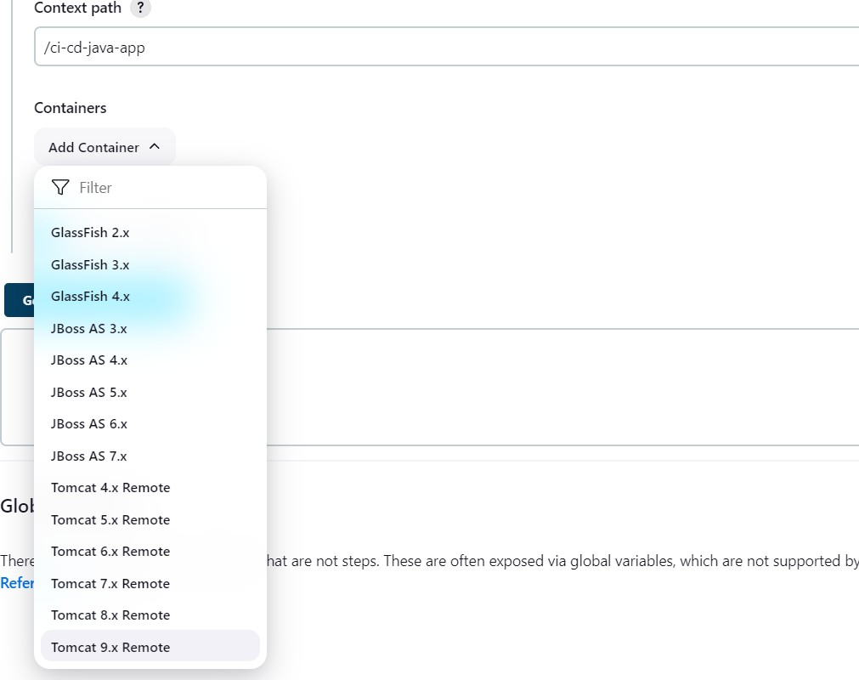

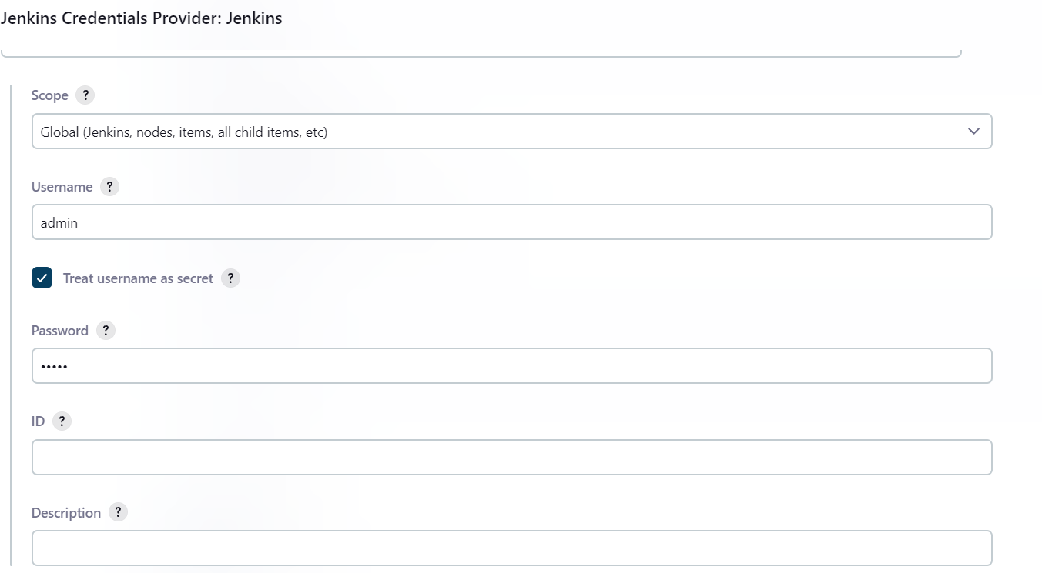

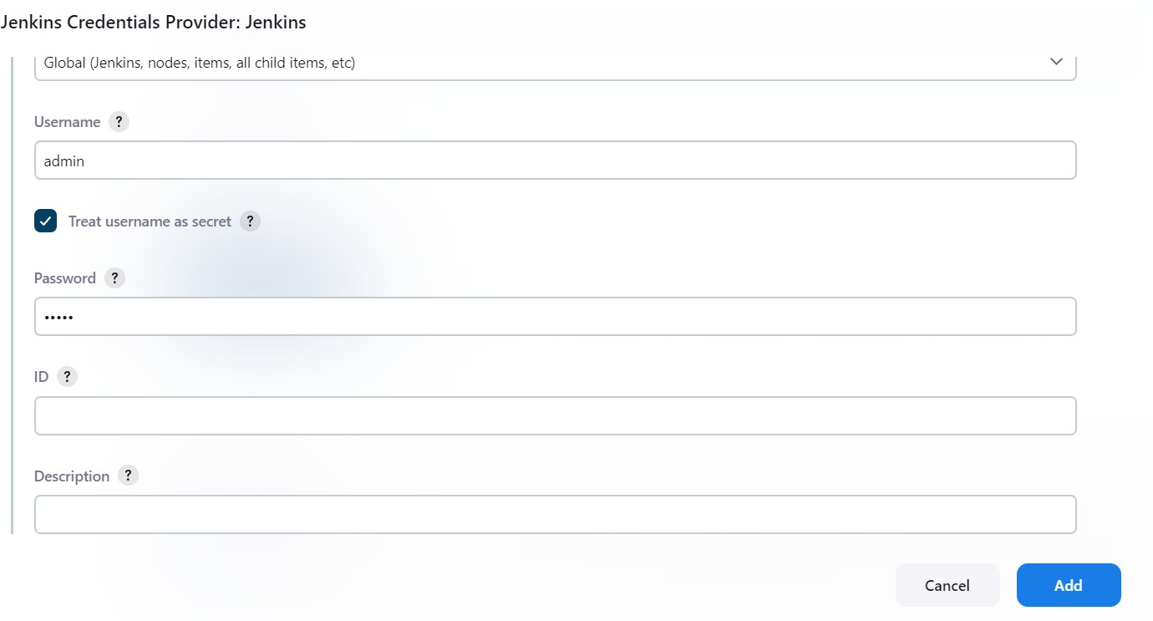

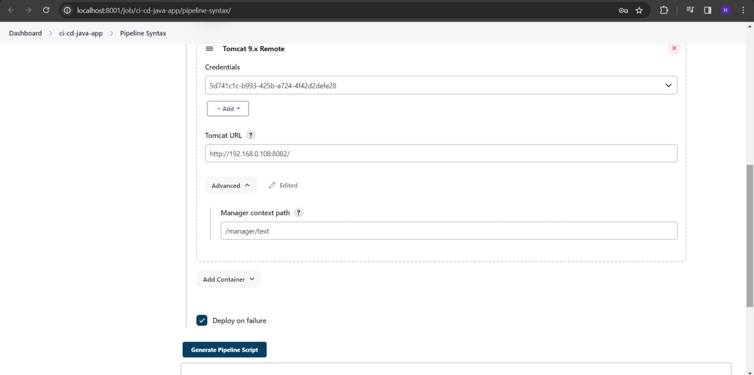

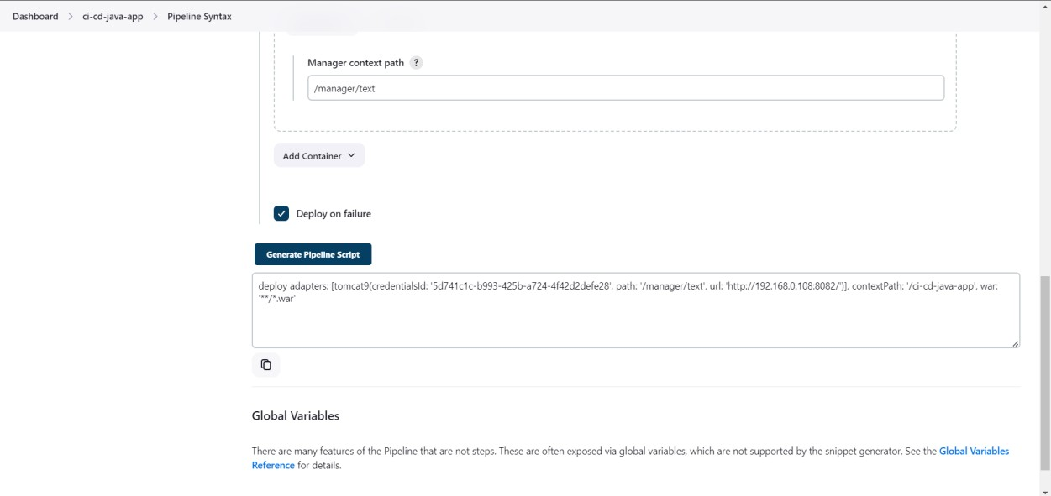

Now paste the syntax generated in the deploy stage of the pipeline code (Jenkinsfile)

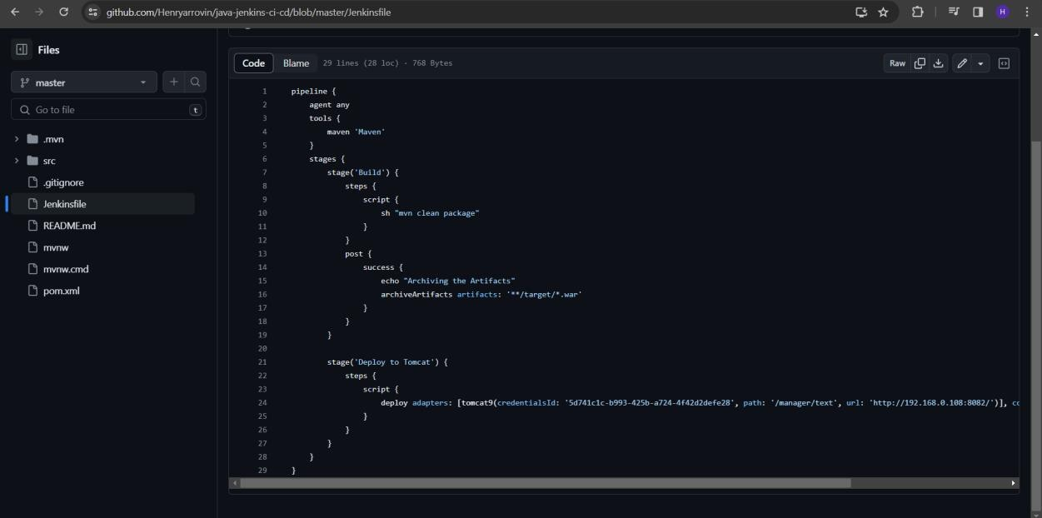

Code: pipeline {

agent any tools {

maven 'Maven'

}

stages {

stage('Build') { steps {

script {

sh "mvn clean package"

}

}

post {

success {

echo "Archiving the Artifacts" archiveArtifacts artifacts: '**/target/*.war'

}

}

}

stage('Deploy to Tomcat') { steps {

script {

// Paste the code generated.

}

}

}

}

}

# Step 3

If we build the pipeline or commit changes, it will be triggered.

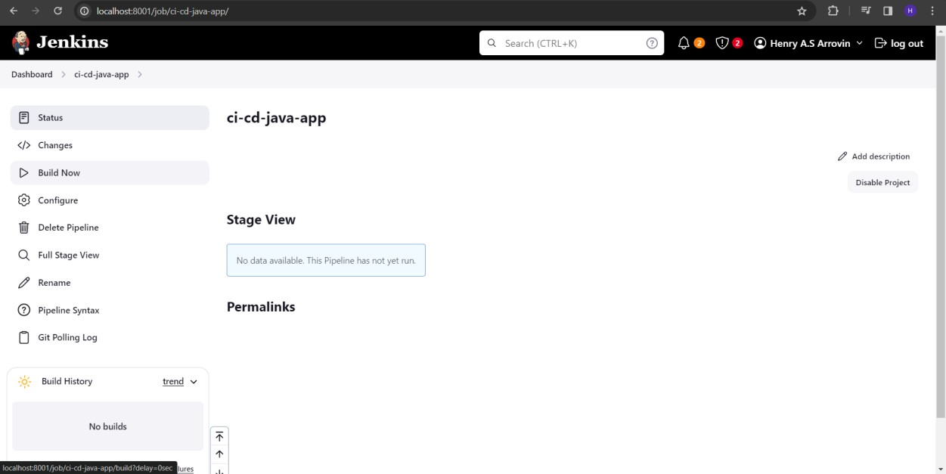

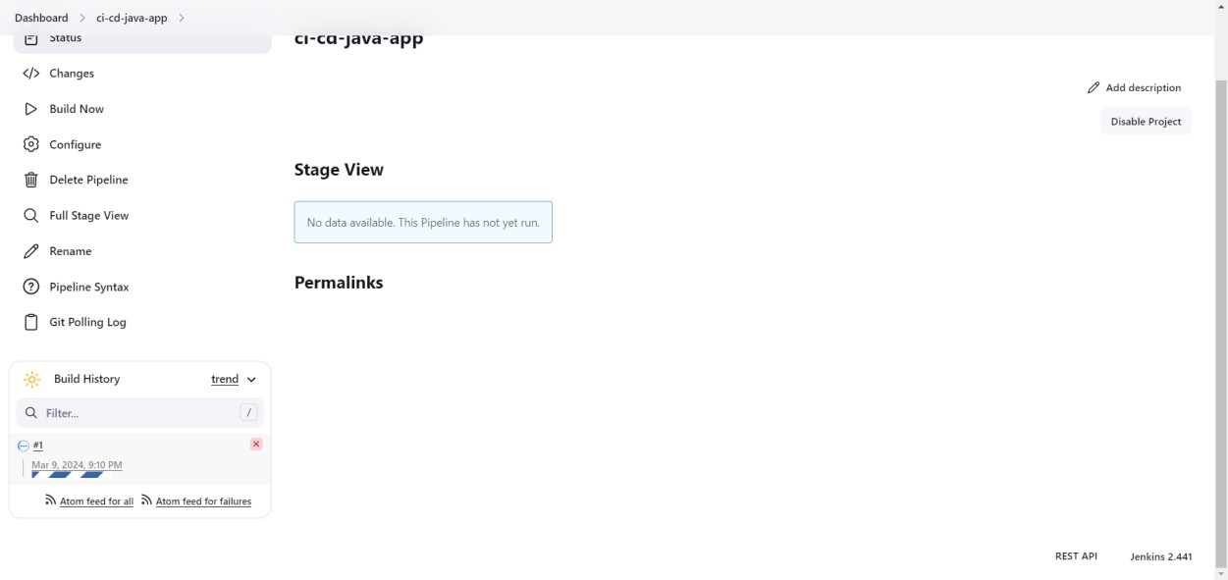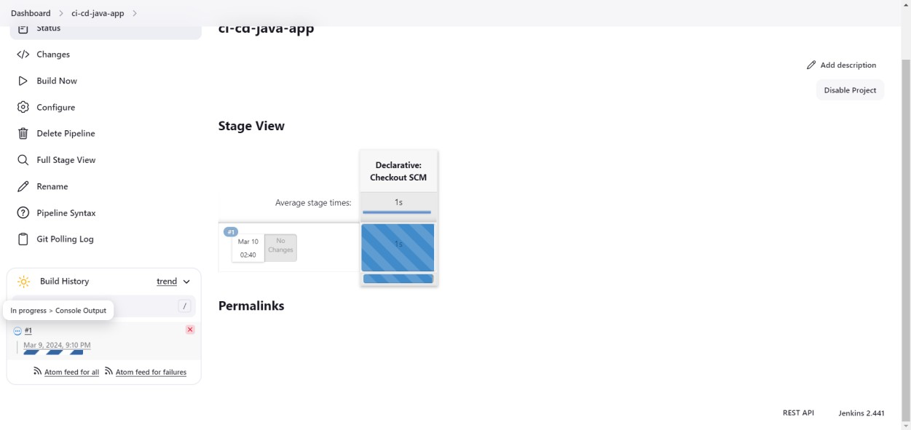

We can also check what is happening properly in the console.

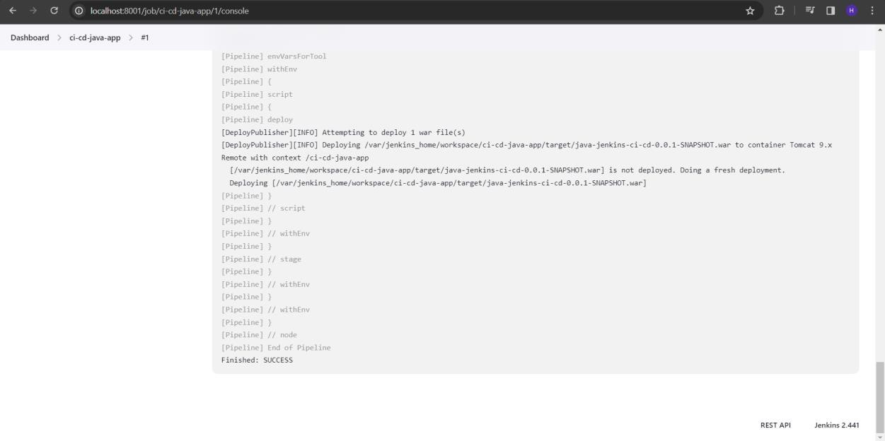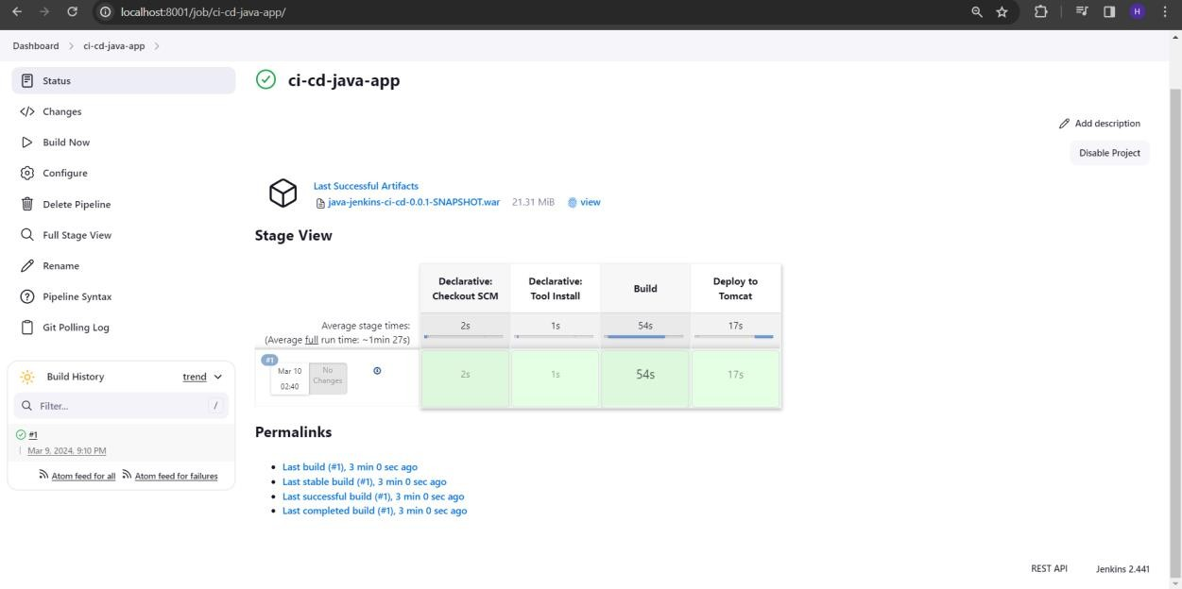

**Conclusion**

Thus, CI pipeline was successfully created using Jenkins

|  |
| --- |
| **Date:** |
| **Ex No: 5** |
| **Create a CD pipeline in Jenkins and deploy in Cloud** |
|  |
| **Aim**  To create a CD pipeline in Jenkins and deploy in Cloud |
| **Procedure**  Install Jenkins:   * If you haven’t already, install Jenkins on your preferred environment (local, cloud VM, or Docker container). Create a Jenkins Job: * Log in to Jenkins. * Click “New Item” to create a new job. * Choose “Pipeline” as the job type.   Configure Your Pipeline:   * In the pipeline configuration, define your stages. A CD pipeline typically includes stages like: * Checkout: Pull your code from the repository. * Build: Compile, package, and create artifacts. * Test: Run automated tests. * Deploy: Deploy to the cloud.   Write Your Jenkinsfile:   * A Jenkinsfile defines your pipeline as code. * Use either declarative syntax or scripted syntax.   Here’s a simple example of a declarative Jenkinsfile:  pipeline {  agent any  stages {  stage('Checkout') {  steps {  checkout scm  }  }  stage('Build') {  steps {  sh 'mvn clean package'  }  }  stage('Test') {  steps {  sh 'mvn test'  }  }  stage('Deploy to Cloud') {  steps {  // Deploy to your cloud provider (e.g., AWS, Azure, GCP)  // Use appropriate tools (e.g., Terraform, Ansible, CloudFormation)  }  }  }  }  Configure Cloud Credentials:   * Add your cloud provider credentials (e.g., AWS access keys, Azure service principal) to Jenkins. * Use the Credentials Plugin to securely manage secrets.   Deploy to Cloud:  In the “Deploy to Cloud” stage, use tools like:   * Terraform: Define infrastructure as code (IaC) and provision resources. * Ansible: Configure servers and services. * CloudFormation: Define AWS infrastructure. * Kubernetes: Deploy containers to a cluster.   Post-Deployment Actions:  After successful deployment, consider additional steps:   * Notifications: Send email notifications or Slack messages. * Monitoring: Set up monitoring and alerts. * Rollbacks: Implement rollback strategies. |

**Ouput**

Now we can check whether our app is deployed in tomcat server in <tomcat- url>/manager/html page.

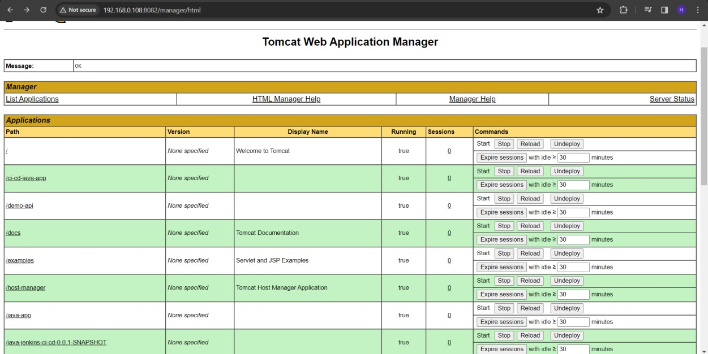

It’ll be in the name of our context path.



# Prerequisite:

Before proceeding, ensure that Tomcat is installed on your system as a prerequisite for this setup.

To start the Tomcat server, navigate to the 'bin' directory and run 'startup.bat' on Windows or './startup.sh' on Ubuntu. To stop the server, use 'shutdown.bat' on Windows or './shutdown.sh' on Ubuntu.

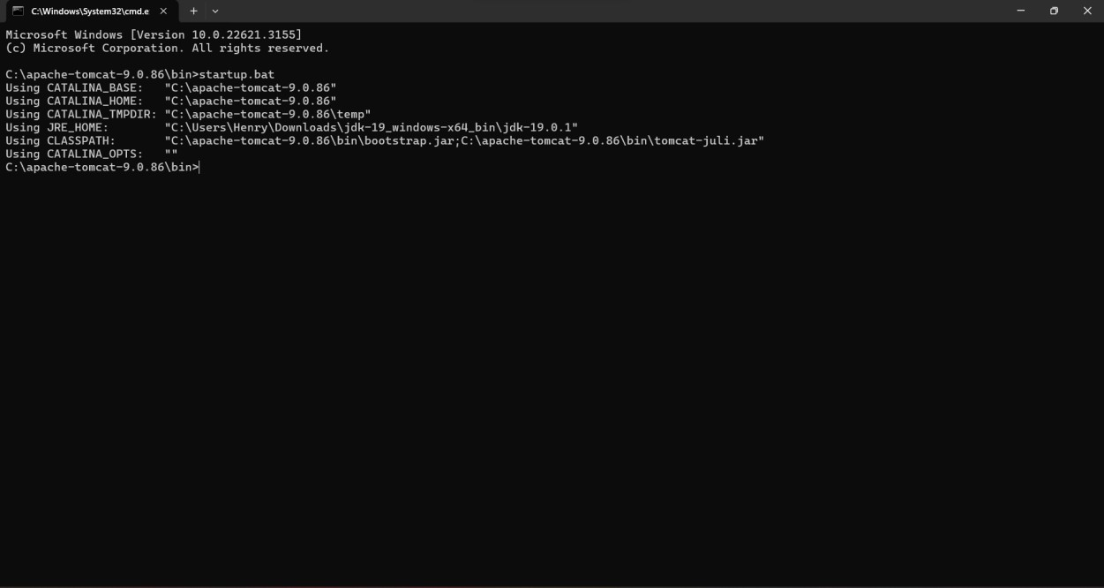

And make sure that maven is configured in Jenkins.

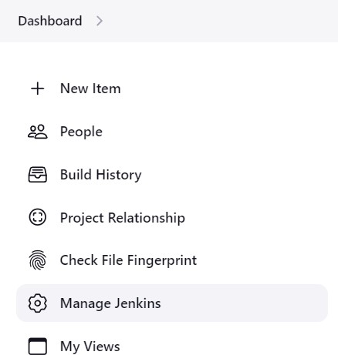

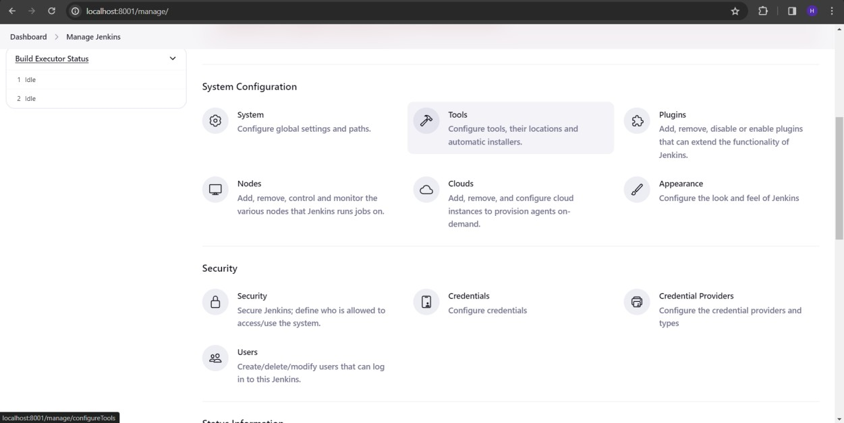

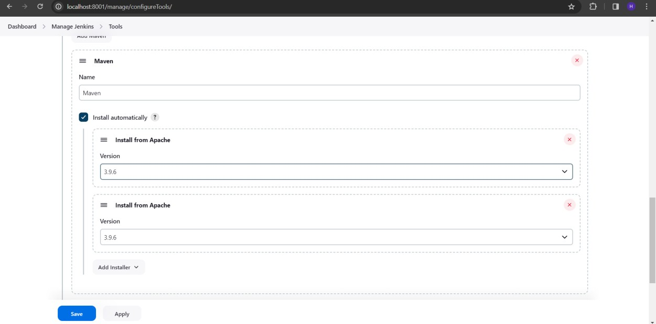

**Conclusion**

Thus, CD pipeline was successfully created using Jenkins

|  |
| --- |
| **Date:** |
| **Ex No: 6** |
| **Build a simple application using Gradle** |
|  |
| **Aim**  To build a simple application using Gradle |
| **Procedure**  1. Install Gradle (if not already done):   * Make sure you have Gradle installed on your system. You can download it from the official Gradle website.       2. Create a Project Directory:   * Open your terminal or command prompt and create a new directory for your project:     mkdir my-java-app  cd my-java-app  3. Create Java Classes:   * Inside your project folder, create a simple Java class for an Employee:   Java  // Employee.java  public class Employee {  private String name;  private String emailAddress;  private int yearOfBirth;  // Constructors, getters, and setters (if needed)  }  Next, create a main class that prints employee data:  Java  // EmployeeApp.java  public class EmployeeApp {  public static void main(String[] args) {  Employee employee = new Employee();  employee.setName("John");  employee.setEmailAddress("john@example.com");  employee.setYearOfBirth(1990);  System.out.println("Name: " + employee.getName());  System.out.println("Email Address: " + employee.getEmailAddress());  System.out.println("Year of Birth: " + employee.getYearOfBirth());  }  }  4. Create a Gradle Build Script:   * In your project folder, create a build.gradle file with the following content:   plugins {  id 'java'  }  repositories {  jcenter()  }  dependencies {  implementation 'org.slf4j:slf4j-api:1.7.32'  testImplementation 'junit:junit:4.13.2'  }  5. Build Your Application:   * Run the following command to build your Java application:   gradle build  Gradle will compile your code, run tests, and create a JAR file in the build/libs directory.  6. Run Your Application:   * Execute the following command to run your application:   gradle run  You’ll see the output |
| **Output** |
| **Conclusion** |
| Thus, a simple gradle application was successfully created and build |
|  |

|  |
| --- |
| **Date:** |
| **Ex No: 7** |
| **Create an Ansible playbook for a simple web application infrastructure** |
|  |
| **Aim**  To create an Ansible playbook for a simple web application infrastructure |
| **Procedure**   1. Install Ansible 2. Update the host file to add the managed host Ips 3. Create a playbook 4. Run the playbook using $ansible-playbook playbookname.yml   **Output**  To check the installation |
| Host file updation  $gedit /etc/ansible/hosts |
| **$ansible main.yml**    **Run the playbook**  **$ansible-playbook main.yml**    **Conclusion**  Thus, an Ansible playbook for a simple application infrastructure was created and tested the code on managed hosts |

|  |
| --- |
| **Date:** |
| **Ex No:8** |
| **Install Ansible and configure ansible roles and to write playbooks** |
|  |
| **Aim**  To install Ansible and configure ansible roles and to write playbooks |
| **Procedure**   1. Install Ansible 2. Update the host file to add the managed hostIPs 3. Create new roles 4. Create a playbook under the roles 5. Run the playbook using $ansible-playbook playbookname.yml   **Output**  To check the installation |
| Host file updation  $gedit /etc/ansible/hosts |
| **To view the files in ansible**  **>> cd /etc/ansible**  **>>ls**  **hosts ansible.cfg roles**  **>>roles**  **>>$ ansible-galaxy init apache**  **>>ls**  **>>tree apache**  **$ansible main.yml**  **Run the playbook**  **$ansible-playbook wintest.yml**    **Conclusion**  Thus, an ansible roles are configured and new playbooks are created and executed successfully |